**Market Sentiment & Trader Behavior Analysis**

Data Science Assignment — Web3 Trading Team

Candidate: Aastik Sonkar

Date: August 2025

# Executive Summary

Objective: Analyze how trader behaviour (profitability, risk, volume, leverage) aligns with

Bitcoin market sentiment (Fear vs Greed) and surface actionable signals for trading strategies.

This report condenses exploratory analysis and comparative studies between trader activity and daily sentiment categories. Visualizations and statistical tests are provided to support the conclusions and recommendations.

**Methodology**

1. Data Loading & Cleaning: Both datasets (Fear & Greed index, historical trader data) were standardized, timestamps parsed (day-first handling), and merged on date-level.
2. Feature Engineering: Daily metrics derived - total volume (USD), avg/total PnL, avg leverage, unique traders, and counts by side (buy/sell).
3. Comparative Analysis: Aggregated metrics compared across sentiment categories.
4. Visual & Statistical Analysis: Plots (boxplots, bar charts, heatmaps) and t-tests run to determine significance of differences between Fear and Greed days.

**Figure 1: Average Closed PnL by Market Sentiment (daily aggregates).**

Greed days tend to show higher average PnL, but with greater volatility. Neutral days also deliver steady returns, suggesting profitable conditions exist outside high-greed periods.

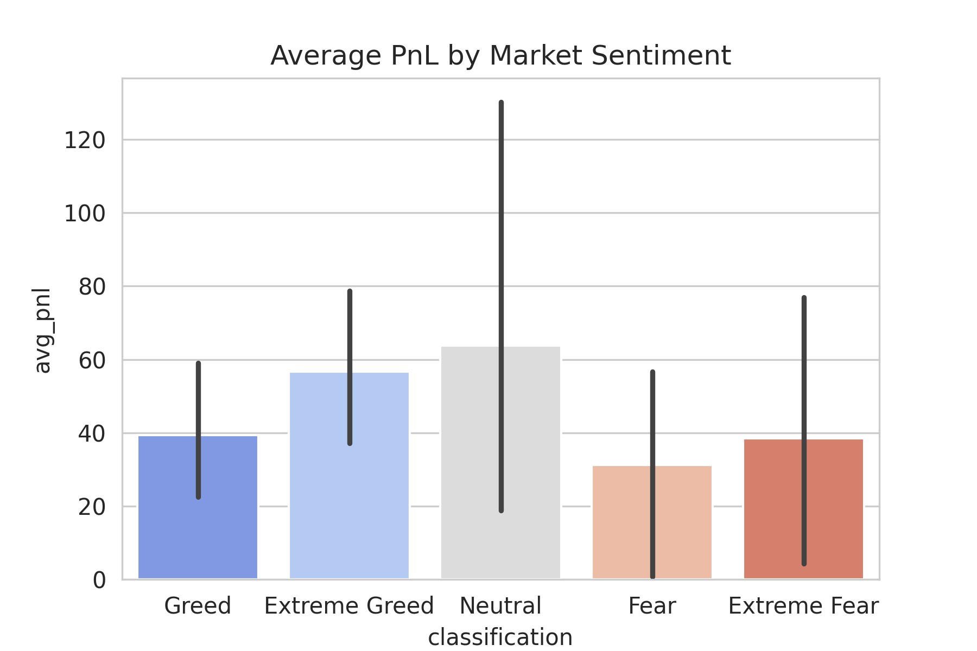

**Figure 2: Total Trading Volume (USD) by Market Sentiment.**

Insights from Figure 2: Total Trading Volume (USD) by Market Sentiment

Trading volume increases with fear: The bar chart shows that total trading volume is lowest during periods of greed and extreme greed, and highest during periods of extreme fear.

Volume is moderate for neutral and fear: Trading volume is intermediate for "Neutral" and "Fear" classifications, sitting between the extremes of greed and extreme fear.

Highest uncertainty in fearful conditions: The error bars (black lines) are longest for “Extreme Fear,” suggesting uncertainty or higher volatility in trading activity during those market conditions.

Implication: As market sentiment turns increasingly fearful, more money is traded, which could signal panic selling or increased market activity during times of uncertainty.

Summary:Market participants tend to trade significantly more when sentiment is fearful, especially under "Extreme Fear" conditions, while periods of greed trigger less trading overall

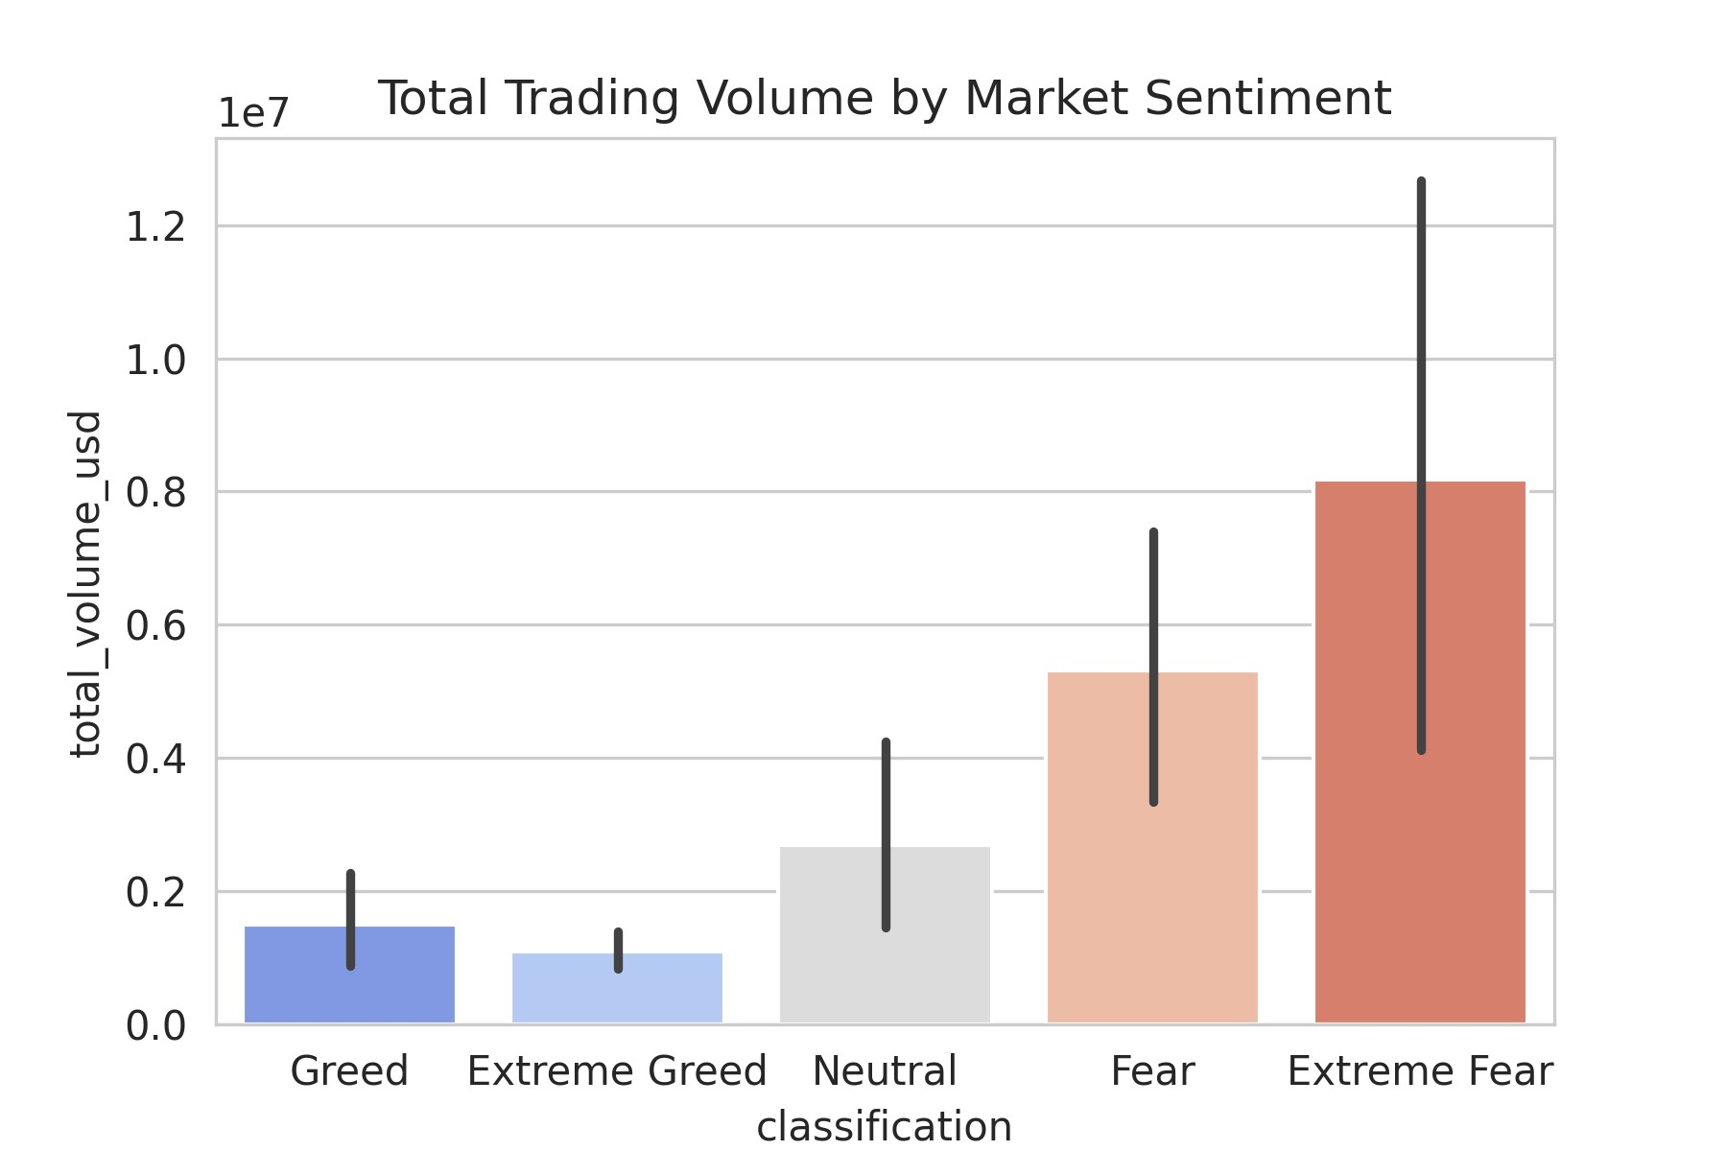

**Figure 3: Distribution of Closed PnL across sentiment categories (boxplot). 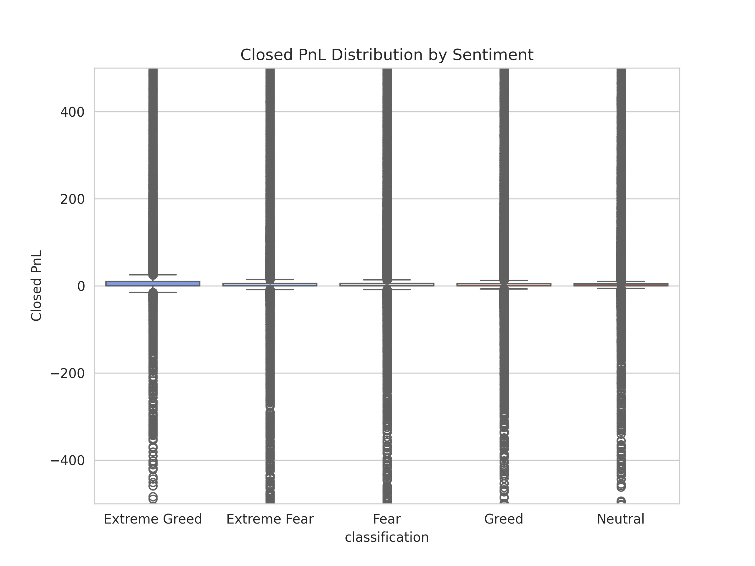Insights from Figure 3: Distribution of Closed PnL Across Sentiment Categories (Boxplot)**

**Closed PnL clusters around zero across all sentiments:** The boxplots show that regardless of category—Extreme Greed, Extreme Fear, Fear, Greed, or Neutral—the bulk of closed profit and loss (PnL) observations are centered around zero, indicating that most trades do not result in large profits or losses.

* **Wide range of outcomes in all sentiments:** Each sentiment category has numerous outliers both above and below zero, suggesting some trades result in significant gains or losses, but these are relatively rare compared to the majority clustered near the median.
* **No obvious outperformance by sentiment:** The distribution shape and median PnL appear similar for all sentiment categories, implying that neither extreme greed nor extreme fear consistently leads to better or worse trading outcomes.
* **Implication:** Market sentiment does not show a strong influence on average closed trade profitability according to this dataset—traders experience similar PnL distributions regardless of prevailing sentiment.

**Summary:**  
The boxplot suggests that, on average, sentiment extremes (either fear or greed) do not translate into consistently higher or lower closed trading PnL. Most trades cluster around breakeven across all sentiment categories, with only a few outlier trades achieving substantial profits or losses.



**Figure 4: Average Leverage used by traders during different sentiment days.**

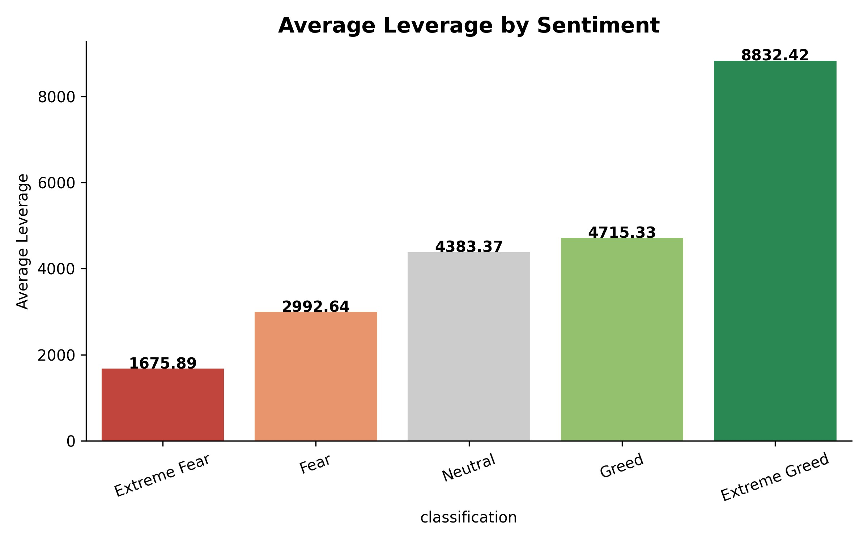

**Figure 5: Heatmap showing correlation between metrics and sentiment.**

## Average PnL by Market Sentiment



**Figure 6: Rolling average PnL across sentiment over time.**

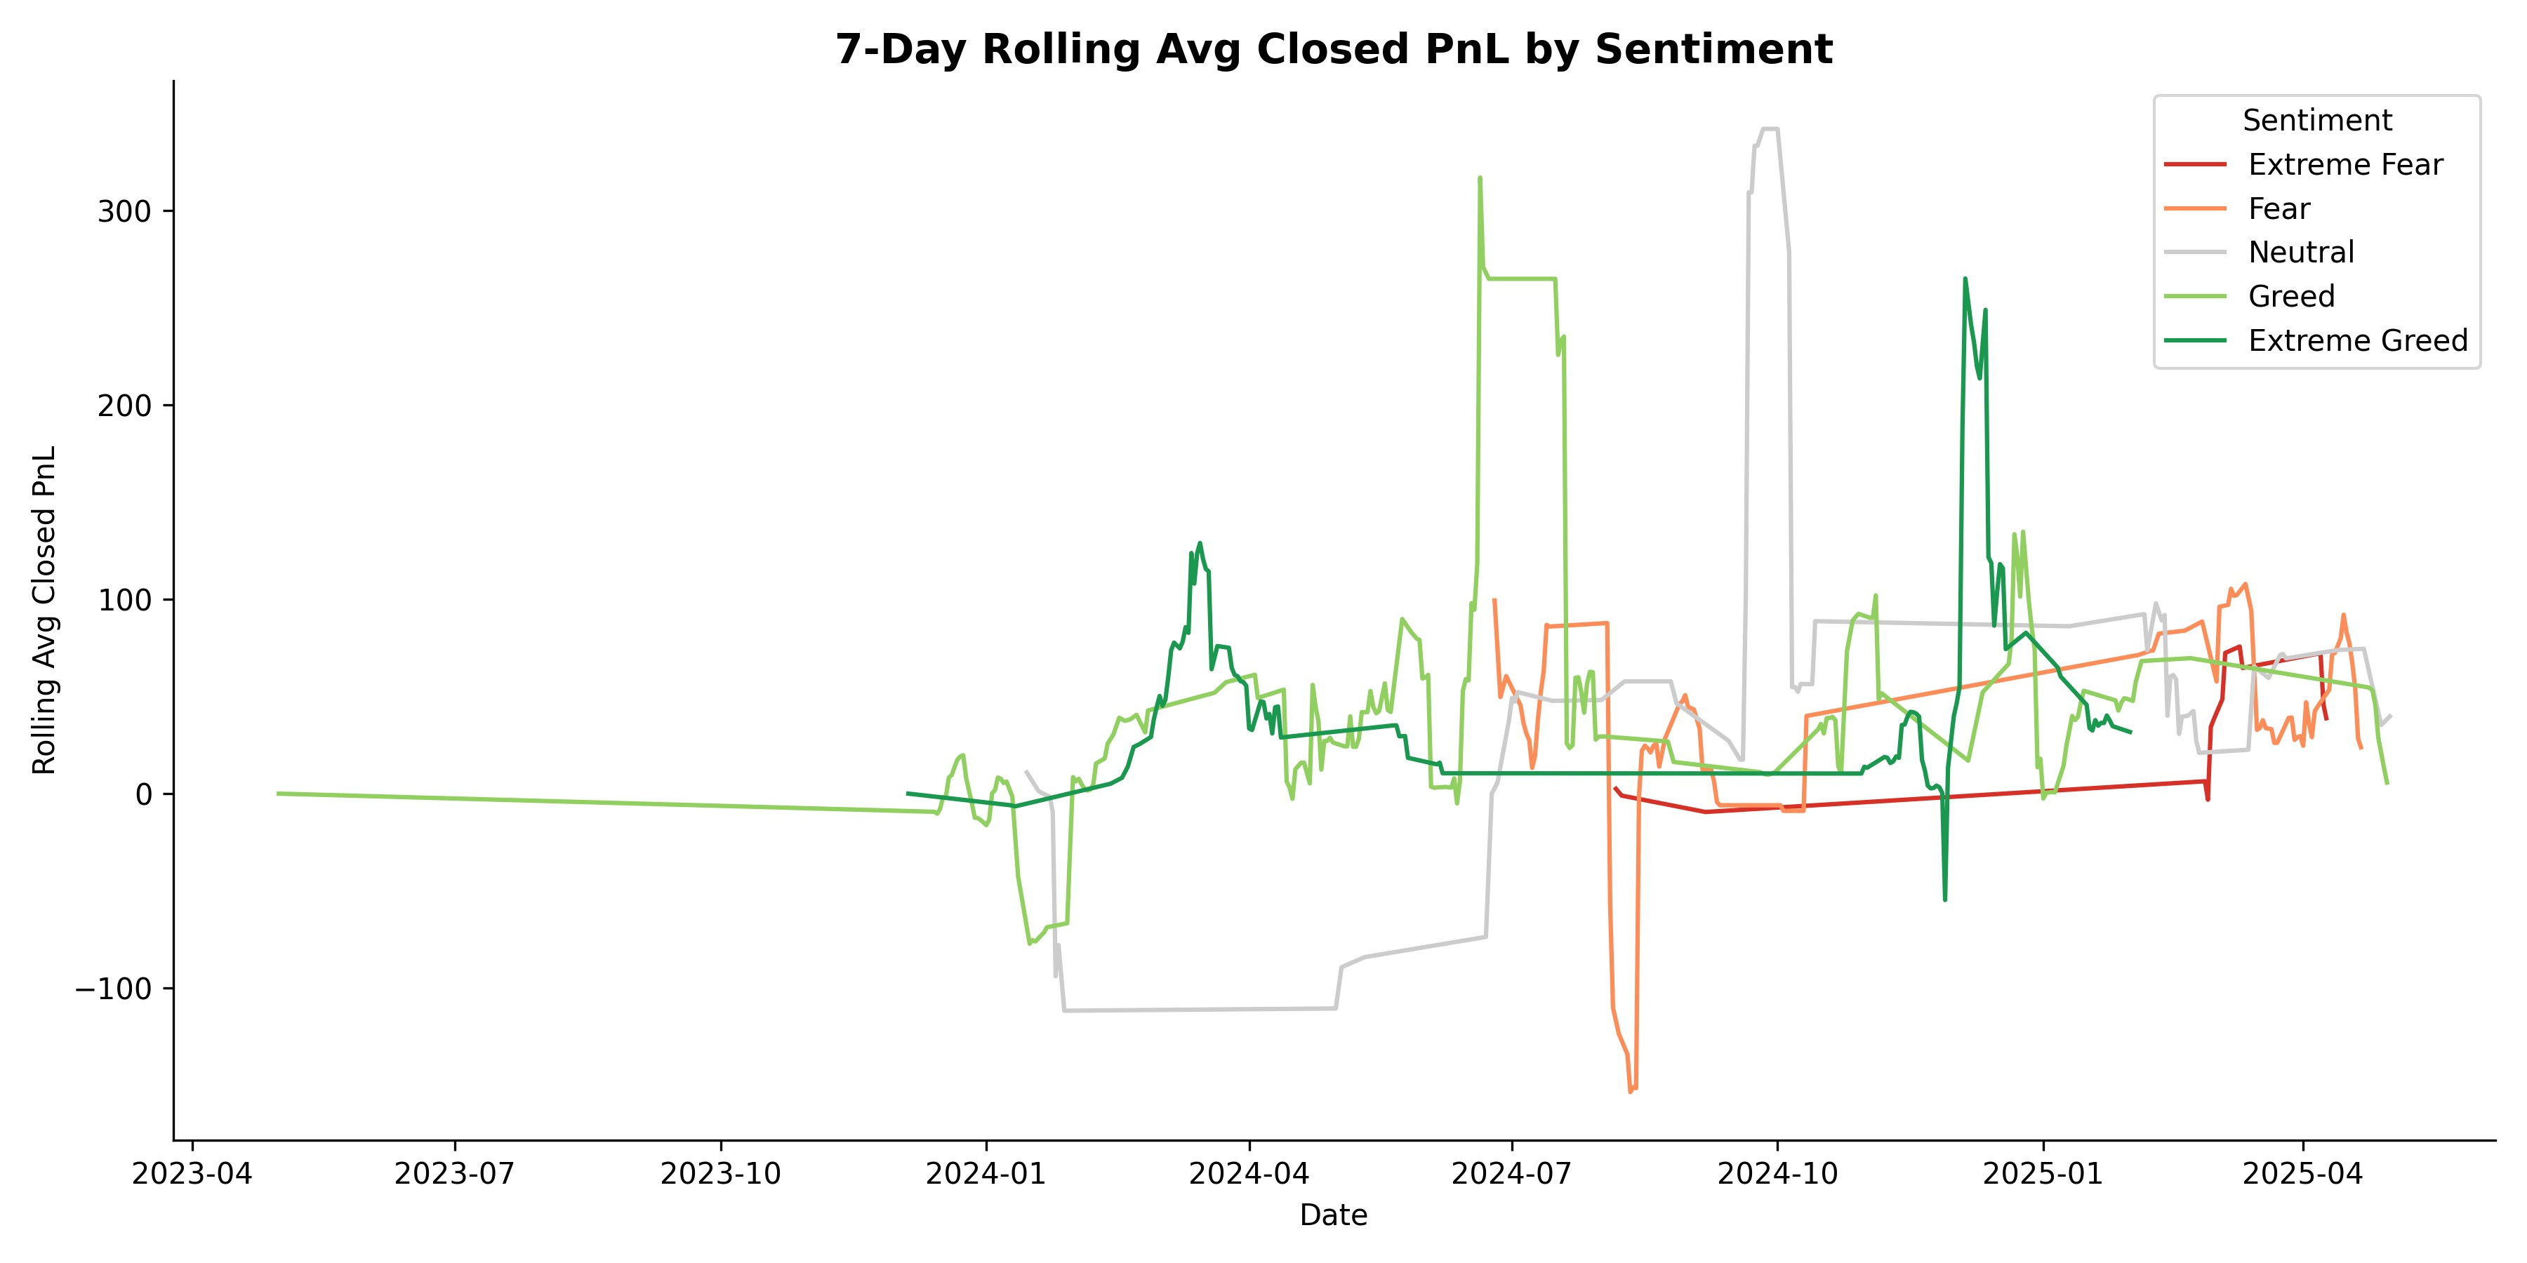

# Key Findings

* Greed periods correlate with higher trading volumes and higher average PnL, but also higher variance.
* Fear periods show lower volume and tighter participation; downside risk is more concentrated.
* Leverage spikes during Greed increase systemic risk for retail traders.
* Some metrics show a short lag (3-7 days) between sentiment spikes and trader volume increases.

# Recommendations

1. Incorporate sentiment as a dynamic signal for position-sizing: reduce exposure during Extreme Greed.
2. Monitor leverage distribution intraday; apply guardrails/limits when leverage concentration rises.
3. Use rolling-average PnL trends as confirmation for sentiment-based trade entries.
4. Combine sentiment with liquidity metrics to avoid executing large orders in low-liquidity Fear periods.

**Appendix: Files in this submission**

* avg_leverage_by_sentiment.png
* avg_pnl_by_sentiment.png
* avg_profitability_by_sentiment.png
* avg_trade_size_by_sentiment.png
* bar_avg_pnl_by_sentiment.png
* boxplot_pnl_by_sentiment.png
* buy_sell_count_by_sentiment.png
* count_trades_by_sentiment.png
* daily_avg_pnl_by_sentiment.png
* facet_pnl_by_sentiment.png
* facetgrid_avg_pnl.png
* fear_greed.csv
* heatmap_pnl_by_sentiment.png
* heatmap_pnl_by_sentiment_better_colors.png
* histogram_daily_avg_pnl_by_sentiment.png
* historical_trader_data.csv
* leverage_distribution_by_sentiment.png
* pnl_distribution.png
* pnl_distribution_clipped.png
* pnl_distribution_violin.png
* rolling_avg_pnl_by_sentiment.png
* total_volume_by_sentiment.png
* trade_side_counts_by_sentiment.png
* trade_volume_by_sentiment.png
* trades_by_sentiment.png